Friends, Families, and Fans,

On behalf of the South Carolina Wrestling Coaches Association and Lexington High School, I would like to take this opportunity to welcome you to the 39th Annual Carolina Invitational Wrestling Tournament. Our tournament staff is very excited about this year’s event and we all look forward to what will surely be an action packed weekend!

This is the third year that the SCWCA has taken over the tournament. All of the wrestlers participating have qualified through one of the region qualifiers that have been held throughout the season all over the state. These are THE BEST middle school and JV wrestlers in the state of South Carolina.

This year’s tournament will consist of 17 Middle School and 14 JV weight classes. Each weight class will have the top 16 wrestlers in that weight. The top three in each weight will receive medals. Team scores will also be kept and the team champion will be recognized.

Since 1974, many of the wrestlers that have participated in this tournament have gone on to be some of the best wrestlers South Carolina has ever produced. We wish you and your team Good Luck and hope that you have a safe and enjoyable weekend!

Yours in wrestling,

Derek Strobel
Lexington High School
Head Wrestling Coach

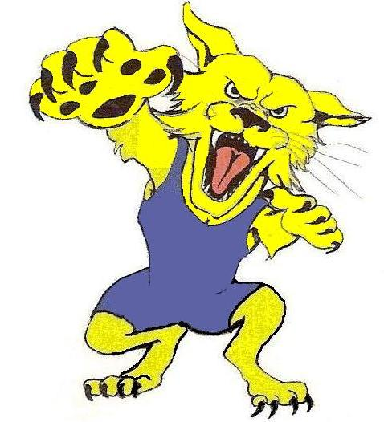

Lexington High School
Drop Off/ Bus Parking

BUS DROP OFF LOCATION
To the left of the gym is a drop off area, drive through let your kids off, they will enter where it says registration. This entrance is for wrestlers entered in the tournament and up to Three Coaches per team. Anyone else must use the Spectator entrance and pay Admission to the tournament.

BUS PARKING LOCATION
After Dropping off Wrestlers the buses need to go into the parking lot and will need go in the direction of the football stadium. The buses will use the parking in front of the Football Stadium. This is to save room closest to the gym for spectators.

Drop Off Area For Wrestlers Entrance for wrestlers to register

Spectator Entrance
Main Gym
2nd GYM GYM
The front of the gym as you turn into Lexington High School
To The Parking area in front of the Stadium
Carolina Invitational
Team Information

Registration
Coaches - Your Entire team must be present for you to register, if not you will be told to wait at the end of the line until your entire team is ready. Registration is at the entrance to the Old Gym, directly in front of the Baseball Field Press Box. You cannot get to registration by going through the main entrance. You will be charged admission.

Weigh-Ins
You will be informed of weigh in locations when you register. The weigh-ins will be held in 1 of 2 locker rooms.

Gym Rules
The New Gym has a NO FOOD OR DRINK policy. Please help us enforce this, Our School Staff works hard to maintain our facilities, if you could ask your kids to keep all food and drinks out of the new gym and keep them in the front lobby and mainly the hall that separates the two gyms this would be greatly appreciated. Trash Cans will also be placed in these spots and replaced regularly, please help our staff maintain your area the best you can.

Food and Tables
We will provide concessions in both gyms.
There will be A LIMITED NUMBER IF ANY tables in the hallway that separates the two gyms but they are first come, first serve. Please keep main walkways open and do not move already placed tables. A parent will not be allowed to enter the registration area to place a cooler at a table, they must pay and use the side hallway to get to the hallway in between the gyms.

***ALL Spectators will come into the gym through the Main Entrance. Admission will be $8.00 per person at the door

***Only Coaches that are members of the SCWCA will be allowed into the hospitality room.

Thirty Ninth Annual
Carolina Invitational Tournament

- Where: Lexington High School
- When: January 21st (Make up date Jan. 28 If necessary)
- Who: Any middle school or JV wrestler that has qualified for this tournament and eligible by “THE SOUTH CAROLINA HIGH SCHOOL LEAGUE”
- Entry Fee: 7 dollars per wrestler
- Admission for spectators $8 dollars for adults and students.
- Awards medals for first three places
- Team awards- JV champion, runner up JV - middle school champion and runner up for single school and consolidated divisions.
- Weigh-In: January 21, 2012 from 7-9 AM in Lexington High School Wrestling Room.
- School coaches must sign and verify that all wrestlers meet High School League Certification at registration. Parent signatures will not be accepted.
- Coaches it would be helpful if you would notify us of any wrestler that qualified but does not plan on attending the tournament. We could give this spot to an alternate.
- Brackets will be 16 man brackets with a double elimination tournament. If case the 5 match rule comes into play, both wrestlers will receive a third place medal.
- Scoring will be according to National Federation rules.
- Questions of who qualified should be directed to the local tournament director. We plan on taking the names sent to us.
- Contact Information: Contact Tommy Bell at Hillcrest High School (864-355-3539) or tbell@greenville.k12.sc.us
Coaches
- Registration from 7:00-9 AM
- Coaches meeting 9 – 9:30 registration packet, location
- Wrestling as soon as possible after 9:30 AM.
Payment
All entry fees for the finals will be made out to the SCWCA
Please bring that check with you to the finals or mail it to:

Tommy Bell
SCWCA Secretary
3665 South Industrial Drive
Simpsonville, SC 29680

Lodging:

Wingate Hotel – Ask for the Lexington Wildcats discount!
803-957-5000
www.lexingtonwingate.com
108 Saluda Pointe Ct
Lexington, SC 29072

Other Hotels in the area:

Holiday Inn- (803) 808-0800 – 5 miles from school (Microwave, refrigerator, continental breakfast)
Hampton Inn- (803) 356-8300 – 4 miles from school (Continental breakfast)
Quality Inn- (803) 359-3099 – 4 miles from school (two queen beds)
Ramada Limited- (803) 356-6533 – 6 miles from school (Continental breakfast

Hospitality Room-
A hospitality room will be sponsored by the SCWCA and Lexington High School. This room is provided for members of the South Carolina Wrestling Coaches Association and tournament workers only.

